Practical 1A
Aim: Intro to TensorFlow

- Create tensors with different shapes and data types.
- Perform basic operations like addition, subtraction, multiplication, and division on tensors.
- Reshape, slice, and index tensors to extract specific elements or sections.
- Performing matrix multiplication and finding eigenvectors and eigenvalues using TensorFlow

Solution:
import tensorflow as tf

# Creating tensors with different shapes and data types
t1 = tf.constant([1, 2, 3], dtype=tf.int32) # 1D tensor (vector)
t2 = tf.constant([[1.5, 2.5], [3.5, 4.5]], dtype=tf.float32) # 2D tensor (matrix)

# Performing basic tensor operations add_result = tf.add(t1, 2) # Adding a scalar
sub_result = tf.subtract(t1, 1) # Subtracting a scalar mul_result = tf.multiply(t1, 2) # Element-wise multiplication div_result = tf.divide(t1, 2) # Element-wise division
# Reshaping, slicing, and indexing tensors
t3 = tf.reshape(t2, [4, 1]) # Reshape to a column vector slice_result = t2[:, 1] # Extracting second column index_result = t1[0] # Extracting first element
# Performing matrix multiplication
mat1 = tf.constant([[1, 2], [3, 4]], dtype=tf.float32)
mat2 = tf.constant([[5, 6], [7, 8]], dtype=tf.float32) mat_mul_result = tf.matmul(mat1, mat2) # Matrix multiplication
# Finding eigenvalues and eigenvectors eigenvalues, eigenvectors = tf.linalg.eig(mat1)

# Printing results
print("Addition:", add_result.numpy()) print("Subtraction:", sub_result.numpy()) print("Multiplication:", mul_result.numpy()) print("Division:", div_result.numpy()) print("Reshaped tensor:", t3.numpy()) print("Sliced tensor:", slice_result.numpy()) print("Indexed element:", index_result.numpy())
print("Matrix multiplication result:\n", mat_mul_result.numpy()) print("Eigenvalues:\n", eigenvalues.numpy()) print("Eigenvectors:\n", eigenvectors.numpy())

Output:
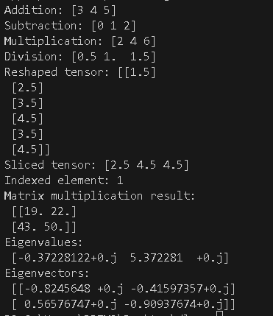

Practical 1B

Aim: Program to solve the XOR problem.

Solution:
import numpy as np
from tensorflow.keras.models import Sequential from tensorflow.keras.layers import Input, Dense from tensorflow.keras.optimizers import Adam

# XOR dataset
X = np.array([[0, 0], [0, 1], [1, 0], [1, 1]])
y = np.array([[0], [1], [1], [0]])

# Build model
model = Sequential()
model.add(Input(shape=(2,))) # Recommended way to define input model.add(Dense(4, activation='relu')) # Hidden layer model.add(Dense(1, activation='sigmoid')) # Output layer

# Compile
model.compile(optimizer=Adam(), loss='binary_crossentropy', metrics=['accuracy'])

# Train
model.fit(X, y, epochs=1000, verbose=0)

# Predict
predictions = model.predict(X)

# Print results print("XOR Predictions:") for i in range(len(X)):
print(f"Input: {X[i]} => Prediction: {np.round(predictions[i][0])}, Actual: {y[i][0]}")

Output:
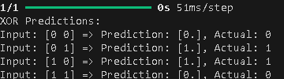

Practical 2: Linear Regression

Aim: Implement a simple linear regression model using TensorFlow's low level API (or tf. keras).
- Train the model on a toy dataset (e.g., housing prices vs. square footage).
- Visualize the loss function and the learned linear relationship.
- Make predictions on new data points.

Solution:
import numpy as np import tensorflow as tf
import matplotlib.pyplot as plt
# 1. Create a toy dataset: Square footage vs Housing prices np.random.seed(42) # For reproducibility
# Square footage (input)
X = np.array([500, 1000, 1500, 2000, 2500, 3000], dtype=np.float32)

# Prices in USD (output)
y = np.array([150000, 200000, 250000, 300000, 350000, 400000], dtype=np.float32)

# Reshape for TensorFlow model input X = X.reshape(-1, 1)
y = y.reshape(-1, 1)

# 2. Define a simple linear regression model model = tf.keras.Sequential([
tf.keras.layers.Input(shape=(1,)), # Proper Input layer to avoid warnings tf.keras.layers.Dense(1) # Linear output layer (slope + intercept)
])

# 3. Compile the model model.compile(optimizer='adam', loss='mse')
# 4. Train the model
history = model.fit(X, y, epochs=1000, verbose=0)

# 5. Plot the training loss (MSE) over epochs plt.plot(history.history['loss']) plt.title('Training Loss (MSE)') plt.xlabel('Epochs')
plt.ylabel('Loss') plt.grid(True) plt.show()

# 6. Visualize the learned linear relationship plt.scatter(X, y, color='blue', label='Data Points') predicted_y = model.predict(X)
plt.plot(X, predicted_y, color='red', label='Fitted Line (Learned)') plt.title('Housing Prices vs Square Footage')

plt.xlabel('Square Footage') plt.ylabel('Price') plt.legend()
plt.grid(True) plt.show()

# 7. Make predictions on new data
new_data = np.array([1200, 1800, 2200], dtype=np.float32).reshape(-1, 1) predictions = model.predict(new_data)

# Print predictions
print(f"Predictions for new data points (Square Footage): {new_data.flatten()}") print(f"Predicted Prices: {predictions.flatten()}")

Output:
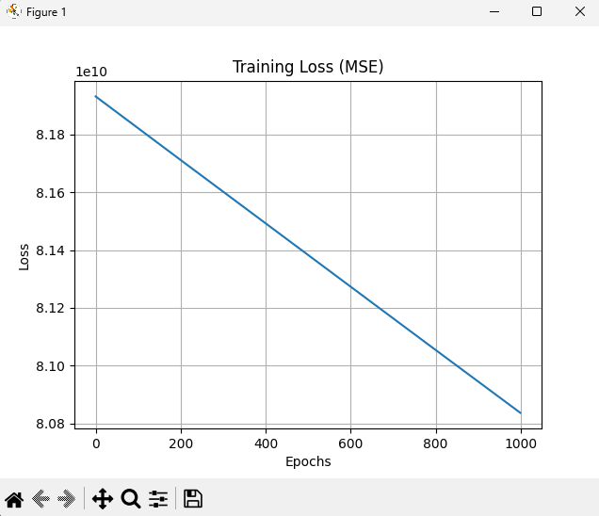
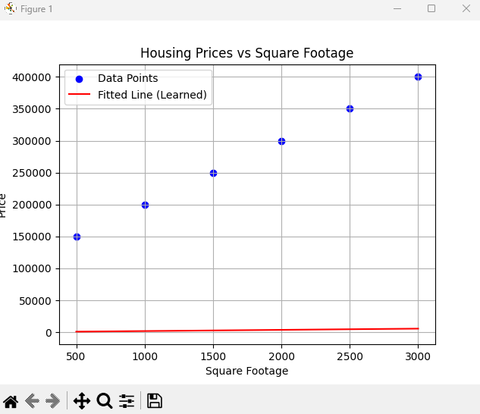

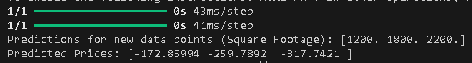

Practical 3A

Aim:Implementing deep neural network for performing binary classification task.

Solution :-
import numpy as np import tensorflow as tf
from tensorflow.keras.models import Sequential from tensorflow.keras.layers import Dense from tensorflow.keras.optimizers import Adam
from sklearn.model_selection import train_test_split from sklearn.preprocessing import StandardScaler from sklearn.datasets import make_classification
# 1. Prepare the Data (You can replace this with your dataset) # Let's generate a synthetic dataset for binary classification
X, y = make_classification(n_samples=1000, n_features=20, n_classes=2, random_state=42)
# Split the data into training and testing sets
X_train, X_test, y_train, y_test = train_test_split(X, y, test_size=0.2, random_state=42)
# Feature scaling (important for neural networks) scaler = StandardScaler()
X_train = scaler.fit_transform(X_train) X_test = scaler.transform(X_test)

# 2. Build the Model model = Sequential()

# Input layer (input shape matches the number of features in the data) model.add(Dense(64, input_dim=X_train.shape[1], activation='relu'))

# Hidden layer
model.add(Dense(32, activation='relu'))

# Output layer (for binary classification, use sigmoid activation) model.add(Dense(1, activation='sigmoid'))

# 3. Compile the Model model.compile(optimizer=Adam(learning_rate=0.001),
loss='binary_crossentropy', # Binary classification loss function metrics=['accuracy'])

# 4. Train the Model

history = model.fit(X_train, y_train, epochs=20, batch_size=32, validation_split=0.2)
# 5. Evaluate the Model
loss, accuracy = model.evaluate(X_test, y_test) print(f"Test Loss: {loss:.4f}")
print(f"Test Accuracy: {accuracy * 100:.2f}%")

Output:
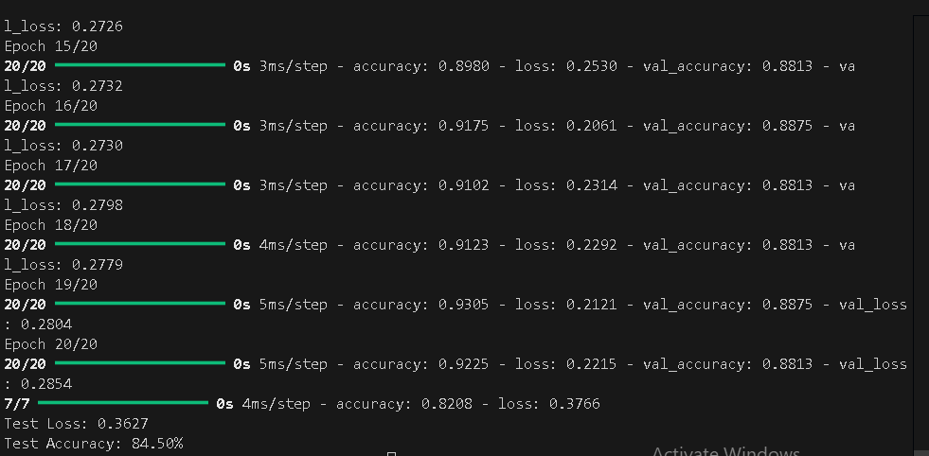

Practical 3B

Aim:Using a deep feed-forward network with two hidden layers for performing multi-class classification and predicting the class.

Solution:-
import numpy as np import tensorflow as tf
from tensorflow.keras.models import Sequential from tensorflow.keras.layers import Dense from tensorflow.keras.optimizers import Adam
from sklearn.model_selection import train_test_split from sklearn.preprocessing import StandardScaler from sklearn.datasets import make_classification from tensorflow.keras.utils import to_categorical

# 1. Prepare the Data (Replace this with your dataset)
# Let's generate a synthetic dataset for multiclass classification # Generate a synthetic multiclass classification dataset
X, y = make_classification(
n_samples=1000, # Number of samples n_features=20, # Number of features n_classes=3, # Number of classes n_clusters_per_class=1, # Reducing clusters per class
n_informative=5, # Increase number of informative features random_state=42
)
# One-hot encode the labels for multi-class classification y = to_categorical(y, num_classes=3)
# Split the data into training and testing sets
X_train, X_test, y_train, y_test = train_test_split(X, y, test_size=0.2, random_state=42)
# Feature scaling (important for neural networks) scaler = StandardScaler()
X_train = scaler.fit_transform(X_train) X_test = scaler.transform(X_test)
# 2. Build the Model model = Sequential()
# Input layer (input shape matches the number of features in the data) model.add(Dense(64, input_dim=X_train.shape[1], activation='relu'))
# Hidden layer 1
model.add(Dense(32, activation='relu')) # Hidden layer 2

model.add(Dense(16, activation='relu'))

# Output layer (for multiclass classification, use softmax activation) model.add(Dense(3, activation='softmax')) # 3 classes in the output
# 3. Compile the Model model.compile(optimizer=Adam(learning_rate=0.001),
loss='categorical_crossentropy', # Categorical cross-entropy loss metrics=['accuracy'])
# 4. Train the Model
history = model.fit(X_train, y_train, epochs=20, batch_size=32, validation_split=0.2)
# 5. Evaluate the Model
loss, accuracy = model.evaluate(X_test, y_test) print(f"Test Loss: {loss:.4f}")
print(f"Test Accuracy: {accuracy * 100:.2f}%")
# 6. Predicting the class for new data
# Example: Predicting the class for a new data point
new_data = np.random.randn(1, X_train.shape[1]) # Random example new_data_scaled = scaler.transform(new_data) # Scale the new data point prediction = model.predict(new_data_scaled)
predicted_class = np.argmax(prediction) # Convert prediction probabilities to the class with highest probability
print(f"Predicted class: {predicted_class}")

Output:-
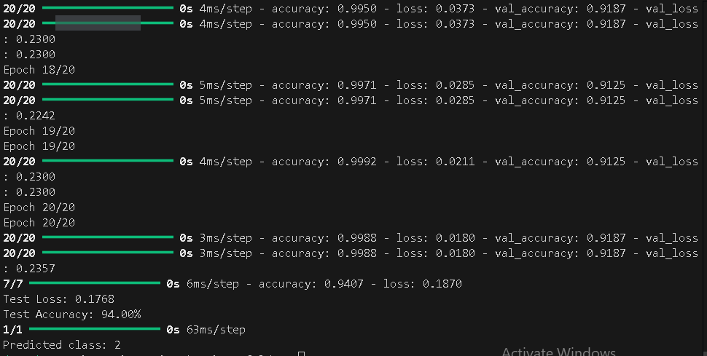

Practical 4

Aim:- Write a program to implement deep learning Techniques for image segmentation

Solution :-

import os import random import torch
import torch.nn as nn import torch.optim as optim
from torch.utils.data import DataLoader, Dataset from torchvision import transforms
from PIL import Image import numpy as np
import albumentations as A # Added Albumentations import

# 1. Define the U-Net Model class UNet(nn.Module):
def init (self, in_channels=3, out_channels=1, init_features=32): super(UNet, self). init()
features = init_features
self.encoder1 = UNet._block(in_channels, features, name="enc1") self.pool1 = nn.MaxPool2d(kernel_size=2, stride=2) self.encoder2 = UNet._block(features, features * 2, name="enc2") self.pool2 = nn.MaxPool2d(kernel_size=2, stride=2)
self.encoder3 = UNet._block(features * 2, features * 4, name="enc3") self.pool3 = nn.MaxPool2d(kernel_size=2, stride=2)
self.encoder4 = UNet._block(features * 4, features * 8, name="enc4") self.pool4 = nn.MaxPool2d(kernel_size=2, stride=2)
self.bottleneck = UNet._block(features * 8, features * 16, name="bottleneck")
self.upconv4 = nn.ConvTranspose2d(features * 16, features * 8, kernel_size=2, stride=2)
self.decoder4 = UNet._block((features * 8) * 2, features * 8, name="dec4")
self.upconv3 = nn.ConvTranspose2d(features * 8, features * 4, kernel_size=2, stride=2)
self.decoder3 = UNet._block((features * 4) * 2, features * 4, name="dec3")
self.upconv2 = nn.ConvTranspose2d(features * 4, features * 2, kernel_size=2, stride=2)
self.decoder2 = UNet._block((features * 2) * 2, features * 2, name="dec2")
self.upconv1 = nn.ConvTranspose2d(features * 2, features, kernel_size=2, stride=2)
self.decoder1 = UNet._block(features * 2, features, name="dec1")

self.conv = nn.Conv2d(in_channels=features, out_channels=out_channels, kernel_size=1)
@staticmethod
def _block(in_channels, features, name): return nn.Sequential(
nn.Conv2d(in_channels=in_channels, out_channels=features, kernel_size=3, padding=1, bias=False),
nn.BatchNorm2d(num_features=features), nn.ReLU(inplace=True), nn.Conv2d(in_channels=features, out_channels=features,
kernel_size=3, padding=1, bias=False), nn.BatchNorm2d(num_features=features), nn.ReLU(inplace=True),
)

def forward(self, x):
enc1 = self.encoder1(x)
enc2 = self.encoder2(self.pool1(enc1)) enc3 = self.encoder3(self.pool2(enc2)) enc4 = self.encoder4(self.pool3(enc3))
bottleneck = self.bottleneck(self.pool4(enc4)) dec4 = self.upconv4(bottleneck)
dec4 = torch.cat((dec4, enc4), dim=1) dec4 = self.decoder4(dec4)
dec3 = self.upconv3(dec4)
dec3 = torch.cat((dec3, enc3), dim=1) dec3 = self.decoder3(dec3)
dec2 = self.upconv2(dec3)
dec2 = torch.cat((dec2, enc2), dim=1) dec2 = self.decoder2(dec2)
dec1 = self.upconv1(dec2)
dec1 = torch.cat((dec1, enc1), dim=1) dec1 = self.decoder1(dec1)
return torch.sigmoid(self.conv(dec1))

# 2. Custom Dataset for Loading Images and Masks class SegmentationDataset(Dataset):
def init (self, image_paths, mask_paths, transform=None): self.image_paths = image_paths
self.mask_paths = mask_paths self.transform = transform

def len (self):
return len(self.image_paths)

def getitem (self, idx): img_path = self.image_paths[idx] mask_path = self.mask_paths[idx]

image = np.array(Image.open(img_path).convert("RGB"))
mask = np.array(Image.open(mask_path).convert("L"), dtype=np.float32) mask[mask == 255.0] = 1.0 # Normalize mask to [0, 1]
if self.transform:
# Apply Albumentations transforms to both image and mask augmented = self.transform(image=image, mask=mask) image = augmented['image']
mask = augmented['mask'] return image, mask
# 3. Training Function
def train_fn(loader, model, optimizer, loss_fn, device): model.train()
running_loss = 0.0
for images, masks in loader: images = images.to(device)
masks = masks.unsqueeze(1).to(device) # Add channel dimension outputs = model(images)
loss = loss_fn(outputs, masks) optimizer.zero_grad() loss.backward() optimizer.step()
running_loss += loss.item() return running_loss / len(loader)

# 4. Evaluation Function
def evaluate_fn(loader, model, loss_fn, device): model.eval()
total_loss = 0.0
with torch.no_grad():
for images, masks in loader: images = images.to(device)
masks = masks.unsqueeze(1).to(device) outputs = model(images)
loss = loss_fn(outputs, masks) total_loss += loss.item()
return total_loss / len(loader)
# 5. Save Model Function
def save_model(model, path): torch.save(model.state_dict(), path) print(f"Model saved to {path}")
# 6. Load Model Function
def load_model(model, path, device): model.load_state_dict(torch.load(path, map_location=device)) model.to(device)

model.eval()
print(f"Model loaded from {path}")

# 7. Prediction Function
def predict_image(model, image_path, transform, device, threshold=0.5): model.eval()
image = np.array(Image.open(image_path).convert("RGB")) original_shape = image.shape[:2] # Save original shape for resizing later

if transform:
# Apply Albumentations transforms (only image needed here) augmented = transform(image=image)
image = augmented['image']

# Add batch dimension and move to device image = image.unsqueeze(0).to(device)

with torch.no_grad(): output = model(image)
# Convert output to binary mask
output = (output.squeeze().cpu().numpy() > threshold).astype(np.uint8) # Resize mask back to original image size
output = np.array(Image.fromarray(output).resize(original_shape[::-1], Image.NEAREST))
return output
# 8. Main Script
if name == " main ": # Hyperparameters LEARNING_RATE = 1e-4 BATCH_SIZE = 8
NUM_EPOCHS = 1
IMAGE_HEIGHT = 128
IMAGE_WIDTH = 128
DEVICE = "cuda" if torch.cuda.is_available() else "cpu" PIN_MEMORY = True
TRAIN_VAL_SPLIT = 0.8 # 80% for training, 20% for validation MODEL_SAVE_PATH = "unet_model.pth"
# Directories
IMAGES_DIR = "/content/data/sub_images" MASKS_DIR = "/content/data/sub_masks"
# Albumentations Transform (Corrected) transform = A.Compose([
A.Resize(IMAGE_HEIGHT, IMAGE_WIDTH), A.Normalize(mean=(0.485, 0.456, 0.406), std=(0.229, 0.224, 0.225)),
A.ToTensorV2(),

], additional_targets={'mask': 'mask'}) # Load all image and mask paths
image_files = sorted([f for f in os.listdir(IMAGES_DIR) if f.endswith(('.jpg',
'.png'))])
mask_files = sorted([f for f in os.listdir(MASKS_DIR) if f.endswith(('.jpg', '.png'))])
# Ensure filenames match
image_names = [os.path.splitext(f)[0] for f in image_files] mask_names = [os.path.splitext(f)[0] for f in mask_files]
assert set(image_names) == set(mask_names), "Mismatch between image and mask filenames"
# Combine full paths
image_paths = [os.path.join(IMAGES_DIR, f) for f in image_files] mask_paths = [os.path.join(MASKS_DIR, f) for f in mask_files]
# Shuffle and split into train/validation combined = list(zip(image_paths, mask_paths)) random.shuffle(combined)
split_index = int(len(combined) * TRAIN_VAL_SPLIT)
train_data, val_data = combined[:split_index], combined[split_index:] train_image_paths, train_mask_paths = zip(*train_data) val_image_paths, val_mask_paths = zip(*val_data)

# Create datasets and dataloaders
train_dataset = SegmentationDataset(train_image_paths, train_mask_paths, transform=transform)
val_dataset = SegmentationDataset(val_image_paths, val_mask_paths, transform=transform)
train_loader = DataLoader(train_dataset, batch_size=BATCH_SIZE, shuffle=True, pin_memory=PIN_MEMORY)
val_loader = DataLoader(val_dataset, batch_size=BATCH_SIZE, shuffle=False, pin_memory=PIN_MEMORY)
# Initialize Model, Loss, Optimizer
model = UNet(in_channels=3, out_channels=1).to(DEVICE) loss_fn = nn.BCEWithLogitsLoss() # Binary Cross Entropy Loss optimizer = optim.Adam(model.parameters(), lr=LEARNING_RATE)
# Training Loop
for epoch in range(NUM_EPOCHS):
train_loss = train_fn(train_loader, model, optimizer, loss_fn, DEVICE) val_loss = evaluate_fn(val_loader, model, loss_fn, DEVICE) print(f"Epoch [{epoch+1}/{NUM_EPOCHS}] | Train Loss: {train_loss:.4f} |
Val Loss: {val_loss:.4f}")
# Save the trained model

save_model(model, MODEL_SAVE_PATH) # Load the model for prediction
loaded_model = UNet(in_channels=3, out_channels=1).to(DEVICE)
load_model(loaded_model, MODEL_SAVE_PATH, DEVICE)
# Perform prediction on a new image
test_image_path = "my_car.webp" # Replace with your test image path predicted_mask = predict_image(loaded_model, test_image_path, transform, DEVICE)

# Save the predicted mask as an image predicted_mask_image = Image.fromarray((predicted_mask * 255).astype(np.uint8)) predicted_mask_image.save("predicted_mask.png")
print("Prediction complete! Predicted mask saved as 'predicted_mask.png'")

output:-

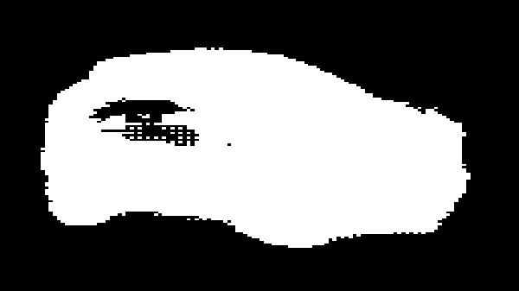

Input Image

Output Image

Practical 5
Aim:- Write a program to predict a caption for a sample image using LSTM.

Solution:-
from tensorflow.keras.applications.vgg16 import VGG16, preprocess_input from tensorflow.keras.preprocessing.image import load_img, img_to_array from tensorflow.keras.models import load_model, Model # <-- Import Model here
from tensorflow.keras.preprocessing.sequence import pad_sequences
import numpy as np import pickle
from PIL import Image

# Load the preprocessed mapping and tokenizer with open("mapping.pkl", "rb") as f:
mapping = pickle.load(f)

def all_captions(mapping):
return [caption for key in mapping for caption in mapping[key]] all_captions = all_captions(mapping)
def create_token(all_captions):
from tensorflow.keras.preprocessing.text import Tokenizer tokenizer = Tokenizer() tokenizer.fit_on_texts(all_captions)
return tokenizer

tokenizer = create_token(all_captions) max_length = 35
def idx_to_word(integer, tokenizer):
for word, index in tokenizer.word_index.items(): if index == integer:
return word return None
def predict_caption(model, image, tokenizer, max_length): in_text = 'startseq'
repeated_word_count = 0 previous_word = None
for i in range(max_length):
sequence = tokenizer.texts_to_sequences([in_text])[0] sequence = pad_sequences([sequence], maxlen=max_length) yhat = model.predict([image, sequence], verbose=0)
yhat = np.argmax(yhat)
word = idx_to_word(yhat, tokenizer)
if word is None or word == 'endseq' or (word == previous_word and repeated_word_count > 2):

break
in_text += " " + word
if word == previous_word:
repeated_word_count += 1

else:
repeated_word_count = 0 previous_word = word
return in_text.strip('startseq ').strip()

# Load the VGG16 model and the captioning model vgg_model = VGG16()
vgg_model = Model(inputs=vgg_model.inputs, outputs=vgg_model.layers[-2].output)
model = load_model("model.keras")

def generate_caption(image_path): try:
# Load and preprocess the image image = Image.open(image_path) image = image.resize((224, 224)) image = img_to_array(image)
image = image.reshape((1, image.shape[0], image.shape[1], image.shape[2]))
image = preprocess_input(image)
feature = vgg_model.predict(image, verbose=0)
# Generate caption
caption = predict_caption(model, feature, tokenizer, max_length)

return caption except Exception as e:
print(f"Error: {str(e)}") return None
# Example usage
if name == " main ":
image_path = "imgdog.jpg" # Replace with your image path caption = generate_caption(image_path)
if caption:
print(f"Generated Caption: {caption}") else:
print("Failed to generate caption.")

output:-

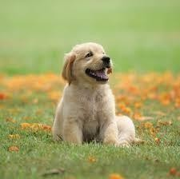
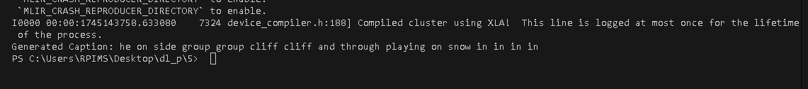

Practical 6

Aim : Applying the Autoencoder algorithms for encoding real-world data

Solution :
# Step 1: Import Libraries import numpy as np import pandas as pd
import matplotlib.pyplot as plt
from sklearn.datasets import load_wine
from sklearn.model_selection import train_test_split from sklearn.preprocessing import MinMaxScaler from tensorflow.keras.models import Model
from tensorflow.keras.layers import Input, Dense from tensorflow.keras.optimizers import Adam
# Step 2: Load Real-World Data data = load_wine()
X = data.data # Features feature_names = data.feature_names
print(f"Dataset shape: {X.shape}") # Step 3: Preprocessing
# Scale the data between 0 and 1 scaler = MinMaxScaler() X_scaled = scaler.fit_transform(X)
# Train-test split
X_train, X_test = train_test_split(X_scaled, test_size=0.2, random_state=42)

print(f"Training set shape: {X_train.shape}") print(f"Testing set shape: {X_test.shape}")
# Step 4: Build Autoencoder Model
input_dim = X_train.shape[1] # Number of features encoding_dim = 8 # Bottleneck size
# Input layer
input_layer = Input(shape=(input_dim,))

# Encoder
encoded = Dense(16, activation='relu')(input_layer) encoded = Dense(encoding_dim, activation='relu')(encoded)
# Decoder
decoded = Dense(16, activation='relu')(encoded)
decoded = Dense(input_dim, activation='sigmoid')(decoded)

# Full Autoencoder
autoencoder = Model(input_layer, decoded)

# Encoder model
encoder = Model(input_layer, encoded)
# Step 5: Compile the Model autoencoder.compile(optimizer=Adam(learning_rate=0.001), loss='mse')
# Step 6: Train the Model history = autoencoder.fit(
X_train, X_train, epochs=100, batch_size=16, shuffle=True,
validation_data=(X_test, X_test)
)

# Step 7: Encode Real-World Data X_encoded = encoder.predict(X_test)

print(f"Encoded data shape: {X_encoded.shape}") print("\nSample Encoded Data:\n", X_encoded[:5])
# Step 8: Plot Loss Curves plt.plot(history.history['loss'], label='Training Loss')
plt.plot(history.history['val_loss'], label='Validation Loss') plt.title('Model Loss During Training')
plt.xlabel('Epochs') plt.ylabel('Loss') plt.legend() plt.show()
# Step 9: Save Encoded Data (Optional)
encoded_df = pd.DataFrame(X_encoded, columns=[f'encoded_{i+1}' for i in range(encoding_dim)])
encoded_df.to_csv('encoded_wine_data.csv', index=False) print("\nEncoded data saved to 'encoded_wine_data.csv'")

Output :

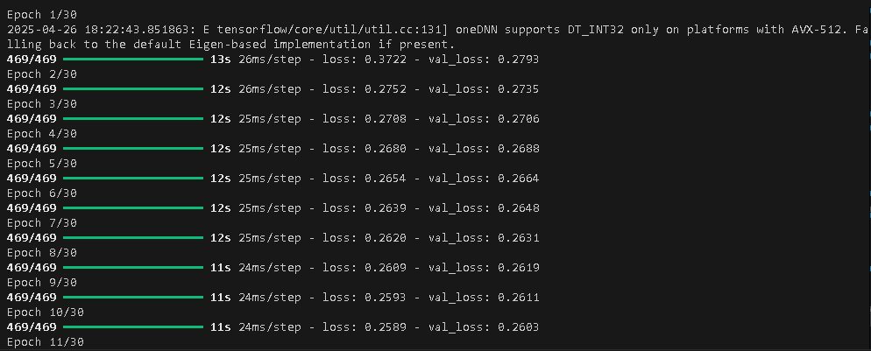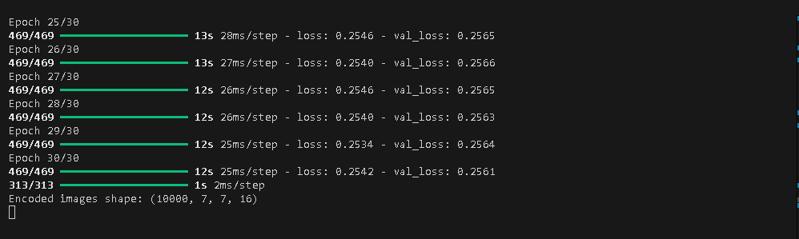
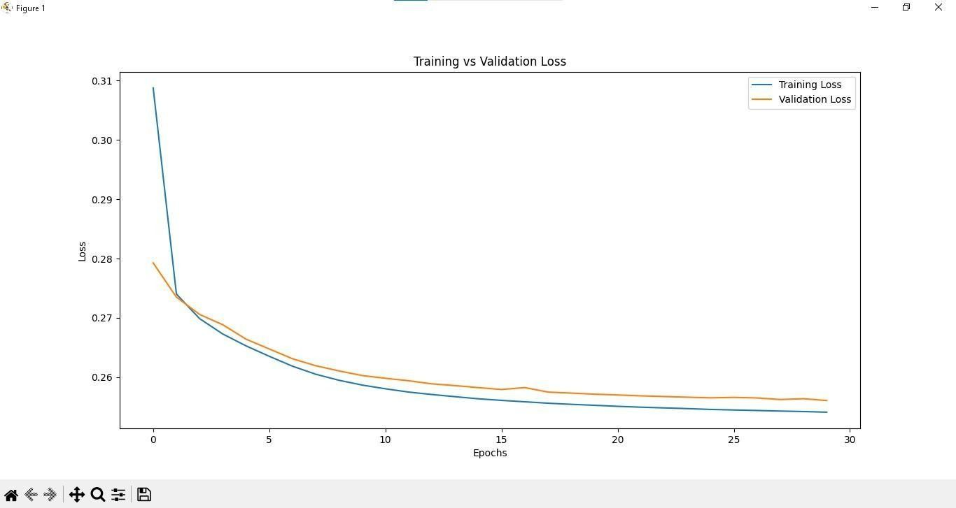

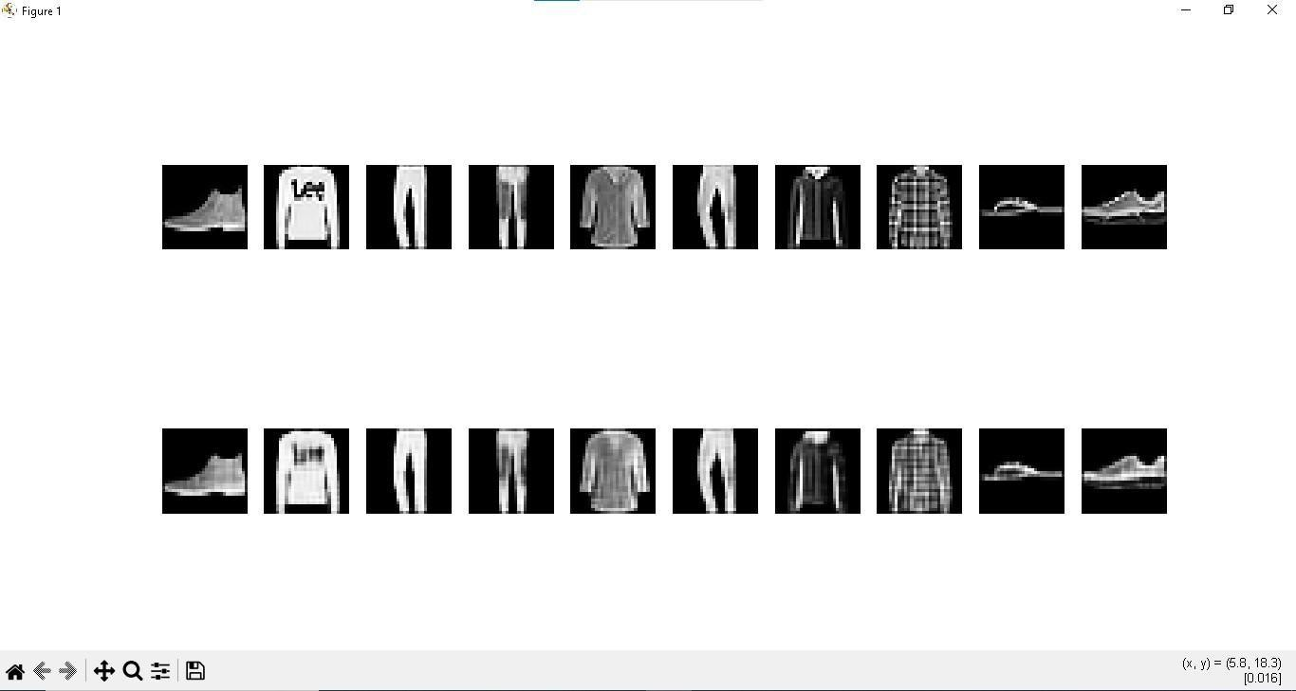

Practical 7

Aim :Write a program for character recognition using RNN and compare it with CNN

Solution :
import tensorflow as tf
from tensorflow.keras import layers, models from tensorflow.keras.datasets import mnist
# Load and preprocess MNIST dataset
(x_train, y_train), (x_test, y_test) = mnist.load_data() x_train, x_test = x_train / 255.0, x_test / 255.0
# Reshape for RNN (samples, timesteps, features)
x_train_rnn, x_test_rnn = x_train.reshape(-1, 28, 28), x_test.reshape(-1, 28,
28)
# Reshape for CNN (samples, height, width, channels)
x_train_cnn, x_test_cnn = x_train.reshape(-1, 28, 28, 1), x_test.reshape(-1,
28, 28, 1)

# RNN Model def create_rnn():
model = models.Sequential([
layers.SimpleRNN(128, activation='relu', input_shape=(28, 28)), layers.Dense(10, activation='softmax')
])
model.compile(optimizer='adam', loss='sparse_categorical_crossentropy', metrics=['accuracy'])
return model

# CNN Model def create_cnn():
model = models.Sequential([
layers.Conv2D(32, (3, 3), activation='relu', input_shape=(28, 28, 1)),
layers.MaxPooling2D((2, 2)), layers.Flatten(),
layers.Dense(128, activation='relu'), layers.Dense(10, activation='softmax')
])
model.compile(optimizer='adam', loss='sparse_categorical_crossentropy', metrics=['accuracy'])
return model

# Train and evaluate RNN rnn_model = create_rnn()
rnn_model.fit(x_train_rnn, y_train, epochs=3, batch_size=64, validation_data=(x_test_rnn, y_test))
rnn_loss, rnn_acc = rnn_model.evaluate(x_test_rnn, y_test)

# Train and evaluate CNN cnn_model = create_cnn()
cnn_model.fit(x_train_cnn, y_train, epochs=3, batch_size=64, validation_data=(x_test_cnn, y_test))
cnn_loss, cnn_acc = cnn_model.evaluate(x_test_cnn, y_test)

# Compare results
print(f'RNN Accuracy: {rnn_acc:.4f}, CNN Accuracy: {cnn_acc:.4f}')

Output :
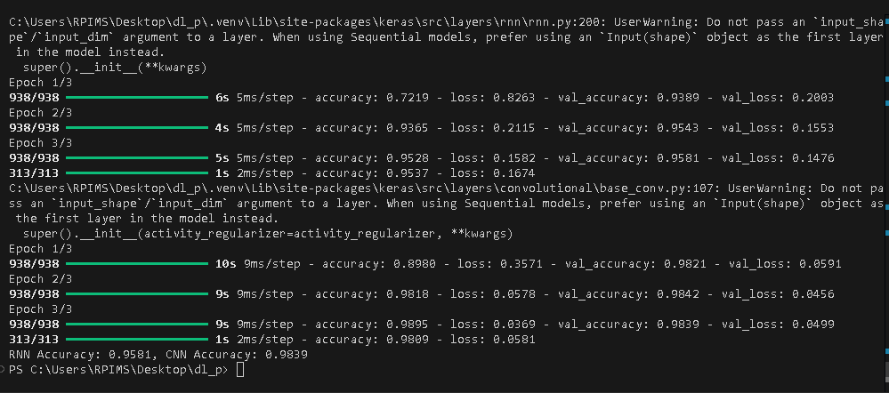

Practical 8

Aim : Write a program to develop Autoencoders using MNIST Handwritten Digits

Solution :
# Step 1: Import Libraries import numpy as np
import matplotlib.pyplot as plt
from tensorflow.keras.datasets import mnist from tensorflow.keras.models import Model
from tensorflow.keras.layers import Input, Dense, Flatten, Reshape from tensorflow.keras.optimizers import Adam
# Step 2: Load and Preprocess Data (x_train, _), (x_test, _) = mnist.load_data()

# Normalize pixel values between 0 and 1 x_train = x_train.astype('float32') / 255.0 x_test = x_test.astype('float32') / 255.0

# Flatten the images (28x28 -> 784)
x_train = x_train.reshape((len(x_train), np.prod(x_train.shape[1:]))) x_test = x_test.reshape((len(x_test), np.prod(x_test.shape[1:])))

print(f"x_train shape: {x_train.shape}") print(f"x_test shape: {x_test.shape}")

# Step 3: Build Autoencoder input_dim = x_train.shape[1] # 784
encoding_dim = 32 # Size of the bottleneck

# Input layer
input_img = Input(shape=(input_dim,))

# Encoder
encoded = Dense(encoding_dim, activation='relu')(input_img)

# Decoder
decoded = Dense(input_dim, activation='sigmoid')(encoded)

# Autoencoder Model
autoencoder = Model(input_img, decoded)

# Encoder Model (for getting encoded data separately) encoder = Model(input_img, encoded)

# Step 4: Compile the Autoencoder

autoencoder.compile(optimizer=Adam(learning_rate=0.001), loss='binary_crossentropy')
# Step 5: Train the Autoencoder history = autoencoder.fit(
x_train, x_train, epochs=50, batch_size=256, shuffle=True,
validation_data=(x_test, x_test)
)

# Step 6: Encode and Decode Some Digits encoded_imgs = encoder.predict(x_test) decoded_imgs = autoencoder.predict(x_test)

print(f"Encoded images shape: {encoded_imgs.shape}")

# Step 7: Visualize the Original and Reconstructed Images n = 10 # Number of digits to display
plt.figure(figsize=(20, 4)) for i in range(n):
# Display original digits
ax = plt.subplot(2, n, i + 1) plt.imshow(x_test[i].reshape(28, 28)) plt.gray()
ax.axis('off')

# Display reconstructed digits ax = plt.subplot(2, n, i + 1 + n)
plt.imshow(decoded_imgs[i].reshape(28, 28)) plt.gray()
ax.axis('off') plt.show()
# Step 8: Plot Training History (Loss curve) plt.figure(figsize=(8, 4)) plt.plot(history.history['loss'], label='Training Loss')
plt.plot(history.history['val_loss'], label='Validation Loss') plt.title('Autoencoder Training vs Validation Loss') plt.xlabel('Epochs')
plt.ylabel('Loss') plt.legend() plt.show()

Output :
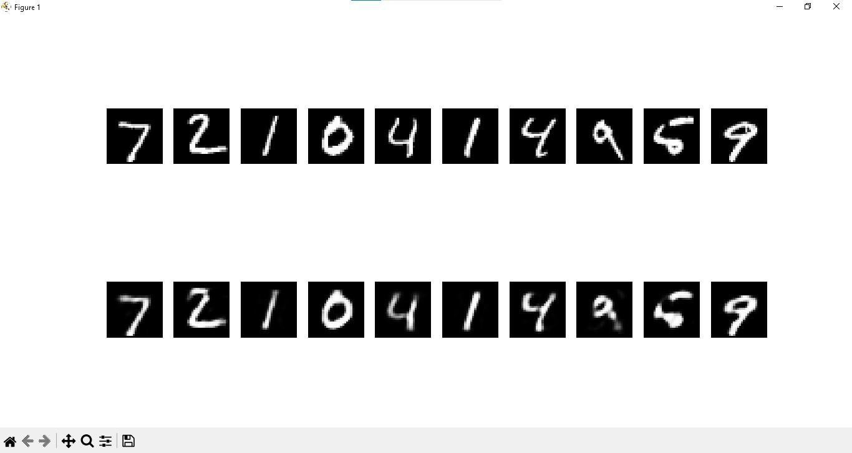

Practical 9

Aim : Demonstrate recurrent neural network that learns to perform sequence analysis for stock price.(google stock price)

Solution :
import numpy as np import pandas as pd import tensorflow as tf
from tensorflow.keras.models import Sequential from tensorflow.keras.layers import LSTM, Dense from sklearn.preprocessing import MinMaxScaler import yfinance as yf

# Fetch historical stock price data using yfinance ticker = 'GOOG'
df = yf.download(ticker, start='2010-01-01', end='2025-02-16') data = df[['Close']].values # Use closing prices

# Normalize data
scaler = MinMaxScaler(feature_range=(0, 1)) data_scaled = scaler.fit_transform(data)
# Prepare training data X_train, y_train = [], []
time_steps = 60 # Use last 60 days to predict next day for i in range(time_steps, len(data_scaled)):
X_train.append(data_scaled[i-time_steps:i, 0])
y_train.append(data_scaled[i, 0])
X_train, y_train = np.array(X_train), np.array(y_train)
X_train = np.reshape(X_train, (X_train.shape[0], X_train.shape[1], 1)) #
Reshape for LSTM
# Build RNN model model = Sequential([
LSTM(units=50, return_sequences=True, input_shape=(X_train.shape[1], 1)),
LSTM(units=50), Dense(units=1)
])

# Compile and train model
model.compile(optimizer='adam', loss='mean_squared_error') model.fit(X_train, y_train, epochs=20, batch_size=32)
# Predict stock prices
predicted_stock_price = model.predict(X_train)
predicted_stock_price = scaler.inverse_transform(predicted_stock_price)

print("Stock Price Prediction Completed!", predicted_stock_price) # #
# Training and testing data splitted and visulization of future predictions

import numpy as np import pandas as pd import tensorflow as tf
import matplotlib.pyplot as plt
from tensorflow.keras.models import Sequential from tensorflow.keras.layers import LSTM, Dense from sklearn.preprocessing import MinMaxScaler import yfinance as yf

# Fetch historical stock price data using yfinance ticker = 'GOOG'
df = yf.download(ticker, start='2010-01-01', end='2025-02-16') data = df[['Close']].values # Use closing prices

# Normalize data
scaler = MinMaxScaler(feature_range=(0, 1)) data_scaled = scaler.fit_transform(data)

# Split data into training and test sets train_size = int(len(data_scaled) * 0.8)
train_data, test_data = data_scaled[:train_size], data_scaled[train_size:]

# Prepare training data X_train, y_train = [], []
time_steps = 60 # Use last 60 days to predict next day for i in range(time_steps, len(train_data)):
X_train.append(train_data[i-time_steps:i, 0])
y_train.append(train_data[i, 0])
X_train, y_train = np.array(X_train), np.array(y_train)
X_train = np.reshape(X_train, (X_train.shape[0], X_train.shape[1], 1)) #
Reshape for LSTM
# Prepare test data X_test, y_test = [], []
for i in range(time_steps, len(test_data)): X_test.append(test_data[i-time_steps:i, 0])
y_test.append(test_data[i, 0])
X_test, y_test = np.array(X_test), np.array(y_test)
X_test = np.reshape(X_test, (X_test.shape[0], X_test.shape[1], 1))
# Build RNN model model = Sequential([
LSTM(units=50, return_sequences=True, input_shape=(X_train.shape[1], 1)),

LSTM(units=50), Dense(units=1)
])

# Compile and train model
model.compile(optimizer='adam', loss='mean_squared_error') model.fit(X_train, y_train, epochs=20, batch_size=32)
# Predict future stock prices future_steps = 30
future_input = test_data[-time_steps:].reshape(1, time_steps, 1) future_predictions = []
for _ in range(future_steps):
pred = model.predict(future_input) future_predictions.append(pred[0, 0])
future_input = np.append(future_input[:, 1:, :], pred.reshape(1, 1, 1), axis=1)
future_predictions = scaler.inverse_transform(np.array(future_predictions).reshape(-1, 1))
# Visualization of future predictions plt.figure(figsize=(14, 5))
future_dates = pd.date_range(df.index[-1], periods=future_steps + 1, freq='B')[1:]
plt.plot(future_dates, future_predictions, label='Future Predictions', color='green')
plt.legend()
plt.title("Future Stock Price Predictions") plt.show()
print("Future Stock Price Prediction Completed!")
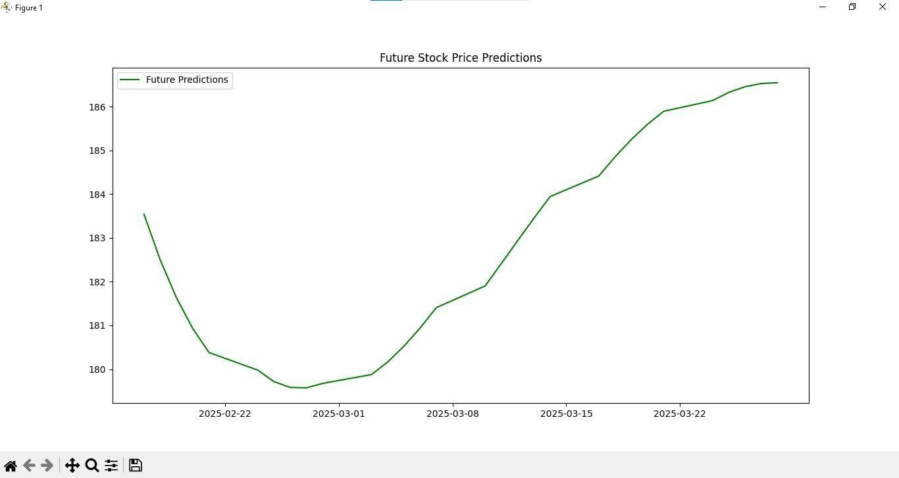

Output:

Practical 10

Aim: Applying Generative Adversarial Networks for image generation and unsupervised tasks.

Solution:

import torch
import torch.nn as nn import torch.optim as optim
from torchvision import datasets, transforms from torch.utils.data import DataLoader import matplotlib.pyplot as plt
# Device
device = torch.device("cuda" if torch.cuda.is_available() else "cpu")

# Hyperparameters latent_dim = 100
batch_size = 64
lr = 0.0002
epochs = 50

# DataLoader for MNIST transform = transforms.Compose([
transforms.ToTensor(),
transforms.Normalize([0.5], [0.5]) # Normalize between [-1, 1]
])
train_data = datasets.MNIST(root='.', train=True, transform=transform, download=True)
train_loader = DataLoader(train_data, batch_size=batch_size, shuffle=True)
# Generator
class Generator(nn.Module): def init(self):
super(). init()
self.model = nn.Sequential( nn.Linear(latent_dim, 128), nn.LeakyReLU(0.2), nn.Linear(128, 256), nn.LeakyReLU(0.2), nn.Linear(256, 784), nn.Tanh()
)

def forward(self, z):
return self.model(z).view(-1, 1, 28, 28)

# Discriminator
class Discriminator(nn.Module): def init(self):
super(). init()
self.model = nn.Sequential( nn.Flatten(), nn.Linear(784, 256), nn.LeakyReLU(0.2), nn.Linear(256, 1), nn.Sigmoid()
)

def forward(self, img): return self.model(img)
# Initialize models
generator = Generator().to(device) discriminator = Discriminator().to(device)
# Loss and optimizers criterion = nn.BCELoss()
optimizer_G = optim.Adam(generator.parameters(), lr=lr) optimizer_D = optim.Adam(discriminator.parameters(), lr=lr)

# Training loop
for epoch in range(epochs):
for batch_idx, (real_imgs, _) in enumerate(train_loader): real_imgs = real_imgs.to(device)
batch_size = real_imgs.size(0)

# Labels
real_labels = torch.ones(batch_size, 1).to(device) fake_labels = torch.zeros(batch_size, 1).to(device)
# Train Discriminator
z = torch.randn(batch_size, latent_dim).to(device) fake_imgs = generator(z)
real_loss = criterion(discriminator(real_imgs), real_labels)
fake_loss = criterion(discriminator(fake_imgs.detach()), fake_labels) d_loss = real_loss + fake_loss
optimizer_D.zero_grad() d_loss.backward() optimizer_D.step()
# Train Generator
z = torch.randn(batch_size, latent_dim).to(device) fake_imgs = generator(z)
g_loss = criterion(discriminator(fake_imgs), real_labels) optimizer_G.zero_grad()

g_loss.backward() optimizer_G.step()
print(f"Epoch [{epoch+1}/{epochs}] D_loss: {d_loss.item():.4f} G_loss:
{g_loss.item():.4f}")
# Show sample generated image if (epoch + 1) % 10 == 0:
with torch.no_grad():
z = torch.randn(16, latent_dim).to(device) samples = generator(z).cpu().numpy() fig, axs = plt.subplots(4, 4, figsize=(4, 4)) for i in range(4):
for j in range(4):
axs[i, j].imshow(samples[i * 4 + j][0], cmap='gray') axs[i, j].axis('off')
plt.show()

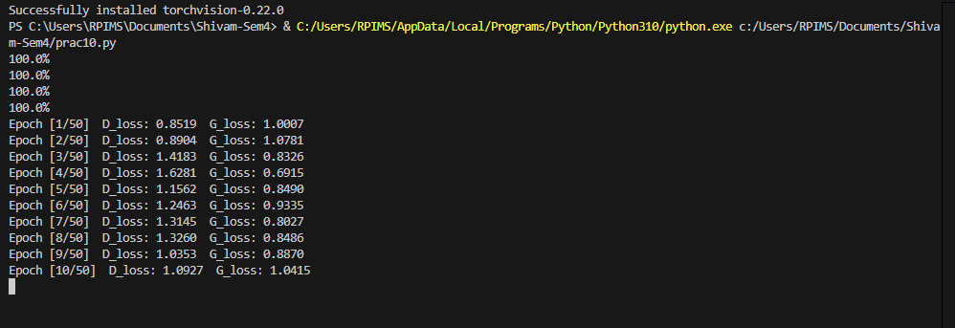

Output:
